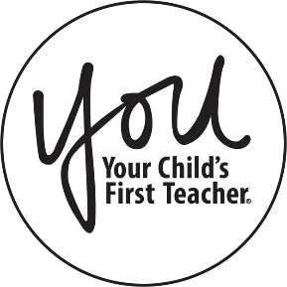
JOIN US FOR A PARENT
WORKSHOP!

East Aurora D131 has partnered with the YOU Program to offer you a workshop titled:

Understanding Assessments

You will learn

. Have a better understanding of Standardized Tests
· The importance of critical thinking.
· Talk to your child’s teacher regularly.
· Both the parent and teacher have the same goal: your child’s academic achievement.

Friday, February 21st, 2020
8:30am to 9:30am

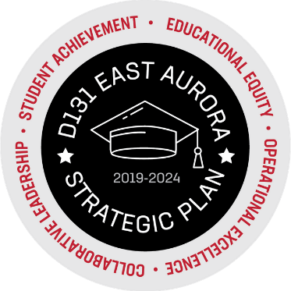
FRED RODGERS ACADEMY
157 N. ROOT STREET AURORA, IL 60505

For more details on this workshop, please contact your Parent Liaison, Alicia Yañez, (630) 299-7177.

