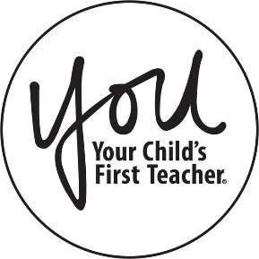
JOIN US FOR A PARENT
WORKSHOP!

East Aurora D131 has partnered with the YOU Program to offer you a workshop titled:

Healthy Living

You will learn

- Healthy Choices
- Family Activities
- Healthy Lifestyles

Friday, January 31st, 2020
8:30am to 9:30am

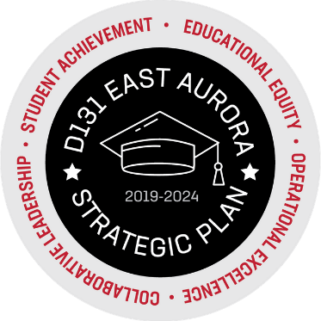
FRED RODGERS ACADEMY
157 N. ROOT STREET AURORA, IL 60505

For more details on this workshop, please contact your Parent Liaison, Alicia Yañez, (630) 299-7177.

