Center for Talent Development
The Cooke Young Scholars Program

Jack Kent Cooke Young Scholars Application Workshop
The Cooke Young Scholars Program is a selective, five-year, precollege scholarship for high-performing 7th graders with financial need.

Interested in details and application assistance? Join us for this free, hands-on workshop, which will provide specifics about the program and help you begin your application.

Workshop Details:

Date: Wednesday, January 22, 2020

Location: Fred Rodgers Magnet Academy Gymnasium 157 N. Root Street
Aurora, IL 60505

Time: 5:00 - 6:15 p.m.

Reserve Your Spot: See back of flyer for registration details.

The distribution of this information and materials does not imply District 131 endorsement.

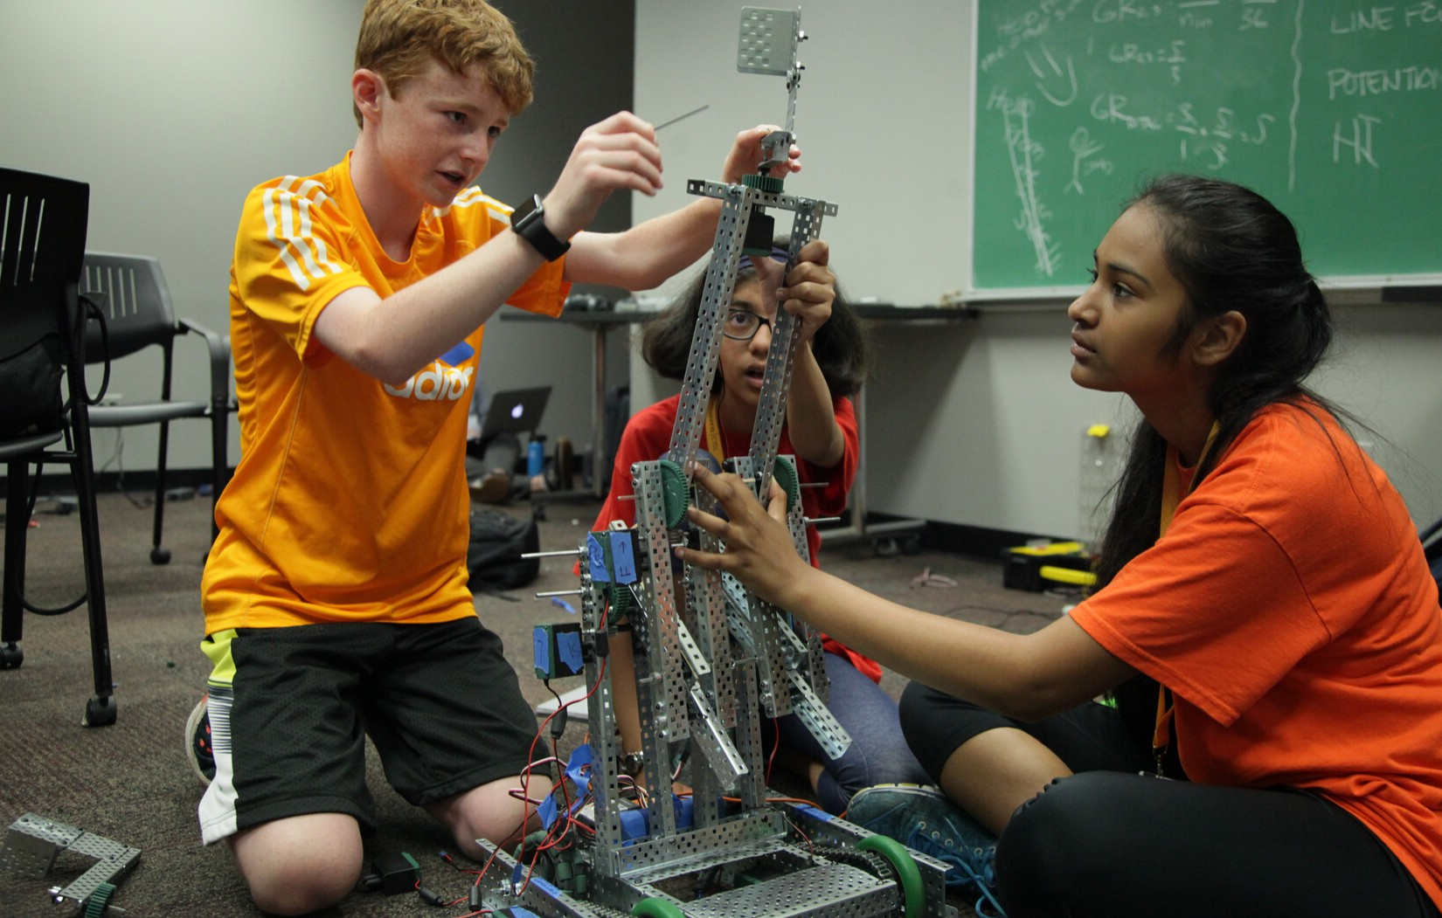

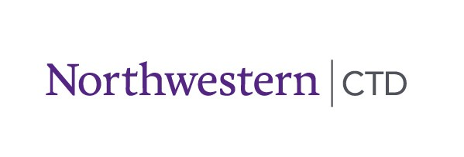

Workshop Details

What is the scholarship?

The Young Scholars Program provides academic and college advising as well as financial support for enrichment opportunities throughout high school. Beginning in 8th grade, Cooke Young Scholars:
- Participate in high-quality academic and extracurricular opportunities in their local community, on college campuses, and around the globe.
- Develop the knowledge, talents, and leadership skills to be significant contributors.
- Set and reach academic and talent goals that will prepare them to be competitive, well-informed applicants for our nation’s best colleges and universities.

Who qualifies for this scholarship?

To be considered for the Young Scholars Program, the applicant must meet the following eligibility requirements:
- Grade level - Entering 8th grade in the fall of 2020
- Academics - Since the beginning of 6th grade, have earned grades of all or mostly A's in school with no C's or below in core academic subjects.
- Testing - Copy of score report from the applicant's state standardized testing. If the applicant has taken above-level testing through a regional talent center, they should also submit those score reports.
- Income - Demonstrate unmet financial need. We will consider applicants with family income up to $95,000.
- Location - Reside in the U.S. or a U.S. territory and plan to attend high school in the U.S.

Why come to the workshop?

The workshop will answer specific questions about the scholarship, review the application sections (parent section, student section, recommendations required, essay), and start the application process. The goal is to help families prepare to complete an on-time application. In addition, families will get additional information about supplemental programs and resources available through Center for Talent Development at Northwestern and similar programs.

A reservation is required. To RSVP:
Email tammie-stewart@northwestern.edu to let her know the names of the people planning to attend. Both a parent/guardian and the applicant should plan to attend the session. Students must be accompanied by an adult to participate.

Questions or want more information about the Jack Kent Cooke Foundation and their scholarships? Contact Tammie Stewart at tammie-stewart@northwestern.edu or visit www.ctd.northwestern.edu/jkc.

