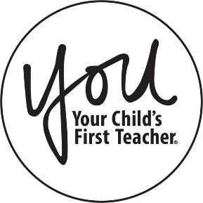
JOIN US FOR A PARENT
WORKSHOP!

East Aurora D131 has partnered with the YOU Program to offer you a workshop titled:

Positive Relationships
You will learn

- Understand why it's important to encourage friendships
- Learn to get to know your child's friends.
- Strategize ways to encourage your child to be a good friend

Friday, November 15, 2019
8:30am to 9:30am

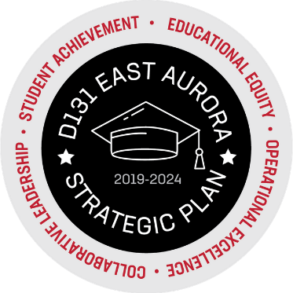
FRED RODGERS ACADEMY
157 N. ROOT STREET AURORA, IL 60505

For more details on this workshop, please contact your Parent Liaison, Alicia Yañez, (630) 299-7177.

