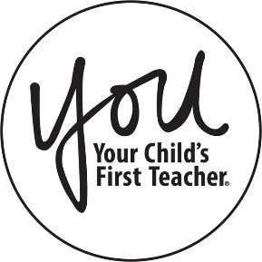
JOIN US FOR A PARENT
WORKSHOP!

East Aurora D131 has partnered with the YOU Program to offer you a workshop titled:

Reading and Literacy
You will learn:
-The importance of reading.

· Reading expands a child’s understanding of the world.

· There is no wasted reading.

· Education is not just limited to the classroom.

Friday, October 18, 2019
8:00am - 9:00am

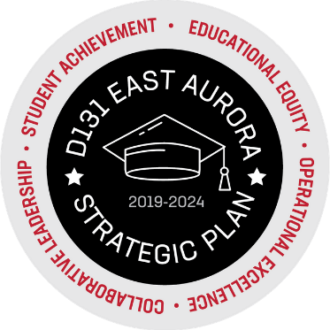
FRED RODGERS ACADEMY
157 N. ROOT STREET AURORA, IL 60505

For more details on this workshop, please contact your Parent Liaison, Alicia Yañez, (630) 299-7177.

