JOIN US FOR A
REGISTER TODAY!
CONTACT: _________________________________

EMAIL: ____________________________________
LOCATION: Fred Rodgers Magnet Academy
157 N. Root St. Aurora, IL. 60505

Questions, please call your parent liaison,
Alicia Yanez 630-299-7177

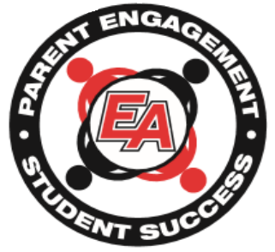
PARENT WORKSHOP!
East Aurora School District 131 has partnered with the YOU Program to offer you a FREE workshop on parent engagement techniques.
DAY/DATE: Friday, February 22nd, 2019
TIME: 8:30 am to 10:00 am
You will learn:
- Your greatest parenting strengths
- How to best partner and communicate with your child’s school
- How to help your child succeed in school
- How to support your child’s physical, social, emotional, and academic development
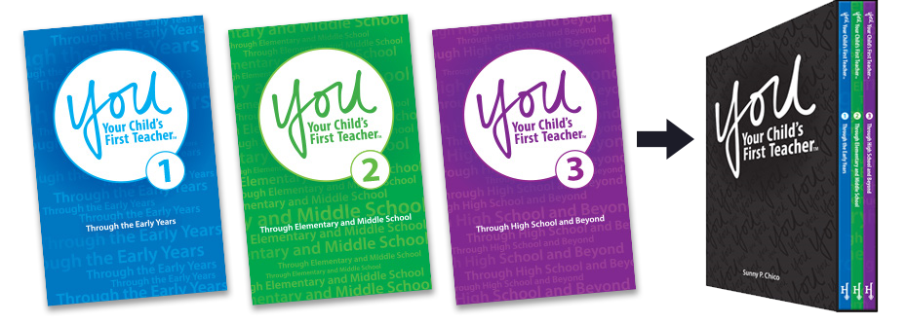
- How to guide your child from birth through high school graduation & beyond

P
R
O
G
R
A
M

F
O
S
T
E
R
S
C
O
L
L
E
G
E

&

C
A
R
E
E
R

R
E
A
D
I
N
E
S
S

Find parenting tips and activities at YouParent.com

