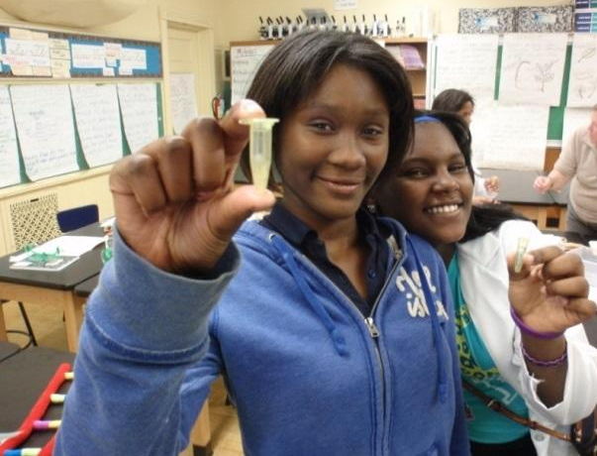
Stellar Girls at Fred Rodgers Magnet Academy is an after-school program for girls in grades 6-8. The program, provided in partnership with the iBIO Institute EDUCATE Center, is designed to spark girls’ interest in Science, Technology, Engineering and Mathematics (STEM) topics and careers through fun and engaging, hands-on activities led by professional educators. Activities are grouped into four units that focus on investigating problems and solutions related to FEEDING, HEALING, FUELING, and SAVING the world.
FRMA
invites YOU to
be a Stellar Girl!
Through this program, girls further their conceptual understanding of STEM topics, develop their hands-on lab and 21st century skills (such as collaboration, communication, creativity, and critical thinking). They discover how what they learn in school can be used to investigate and solve real-world problems. The program also provides opportunities for girls to interact with professionals working in STEM fields. Now in its fifth year, the Stellar Girls program is an excellent way to develop girls’ learning, self-confidence, and interest in STEM topics and careers.

ABOUT FRED RODGERS MAGNET ACADEMY’S 2018–2019

WHO can participate? FRMA girls in grades 6 to 8
WHERE will we meet? Room 313 (Mrs. Christianson’s Classroom)
WHEN will we meet? Stellar Girls sessions will meet most Fridays from 3:15 to 4:45 pm, beginning October 26. A more specific schedule will be provided at the beginning of the program.
HOW do I sign up? To sign up for Stellar Girls, complete and return the following documents and bring to the first meeting. I will also have hard copies available at that time.

For further information, please contact Mrs. Nicol Christianson @ nchristianson@d131.org

2018-2019

Yes! _____________________________________________________, in grade _____________,
(Full name of student) (Grade level)

will participate in Fred Rodgers Magnet Academy’s Stellar Girls after-school STEM program that will occur on Fridays, from 3:15 - 4:45 pm, beginning October 26, 2018.
We understand that regular and active participation in program activities, in addition to completion of all pre- and post-assessments is required.
NOTE: Be sure to read, sign and return the parent/guardian consent and the student assent forms along with this form.

Student ____________________________________________ Date: ____________________________
(Signature)

Student ____________________________________________ ID # ______________________________
(Printed name)

Parent/Guardian ______________________________________ Date: ____________________________
(Signature)

Parent/Guardian ______________________________________, _________________________________
(Printed name) (Relationship to student)

Contact Information: ____________________________________ _______________________________
(e-mail) [phone number(s)—indicate (H), (W), (C)]

Emergency Contact(s)

___________________________ ________________________ ________________________________
(Name) (Relationship to student) [phone number(s)—indicate (H), (W), (C)]

___________________________ ________________________ ________________________________
(Name) (Relationship to student) [phone number(s)—indicate (H), (W), (C)]

_____________________________ ___________________________ ___________________________________
(Name) (Relationship to student) [phone number(s)—indicate (H), (W), (C)]

