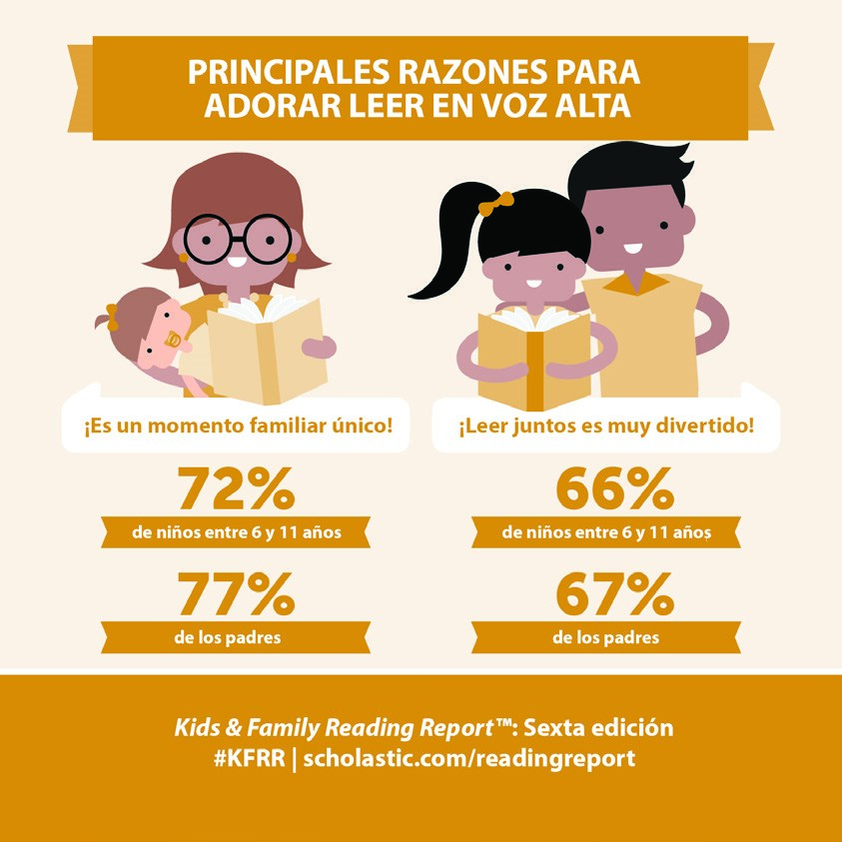

Estimados padres y familias de Magnet:
¡Leer un promedio de 20 minutos al día es una de las
maneras más fáciles de desarrollar el vocabulario y
las habilidades de lectura de su hijo/hija y, al mismo
tiempo, optimizar sus calificaciones! A los niños les
encanta leer en familia y lo disfrutan aún más cuando
ellos eligen sus propios libros.
Considere las siguientes sugerencias para animar su
lectura:
•

Lea en voz alta en familia.
•

Tenga libros en casa. Con cada adición a la biblioteca
de su hogar, estará ayudando a su hijo/hija a avanzar
un poco más en la escuela.
•

Visite la biblioteca y deje que su hijo/hija elija sus propios libros.
•

Lea lo que está leyendo su hijo/hijo y comenten la historia.
•
Predique con el ejemplo. Los niños se inspiran cuando ven que usted también disfruta la lectura.
•
Traiga a su hijo/hija a la Feria del Libro y descubran juntos nuevos libros.
Nuestra Feria del Libro de Scholastic ofrece una gran selección de libros atractivos y asequibles
para todas las edades.
¡Con certeza, aquí su hijo/hija encontrará libros que le encantarán! Por favor, planifique una visita a
nuestra Feria del Libro.
Fechas de la Feria del Libro: Del 12 al 16 de Marzo, 2018
Horario comercial: de las 11:18 AM a la 1:30 PM y de 3 a 3:15 PM

Antes de visitarnos, descargue la aplicación de las ferias del libro y converse con su hijo/hija sobre
los libros que les parezcan interesantes. Busque “Book Fairs” en la tienda de aplicaciones (app store)
o visite
scholastic.com/apps/bookfairs
.
Si no puede asistir en persona, puede comprar en nuestra feria online desde el 7 de Marzo
hasta el
20 de Marzo
en
scholastic.com/fair
.
¡Los esperamos en nuestra Feria del Libro! Recuerde, todas las compras estarán beneficiando a
nuestros estudiantes. ¡Gracias por apoyar a nuestros lectores!

© 2018 Scholastic Inc. All rights reserved. 14427 S18
300274
Permission to reproduce this item is granted by Scholastic Book Fairs®.

