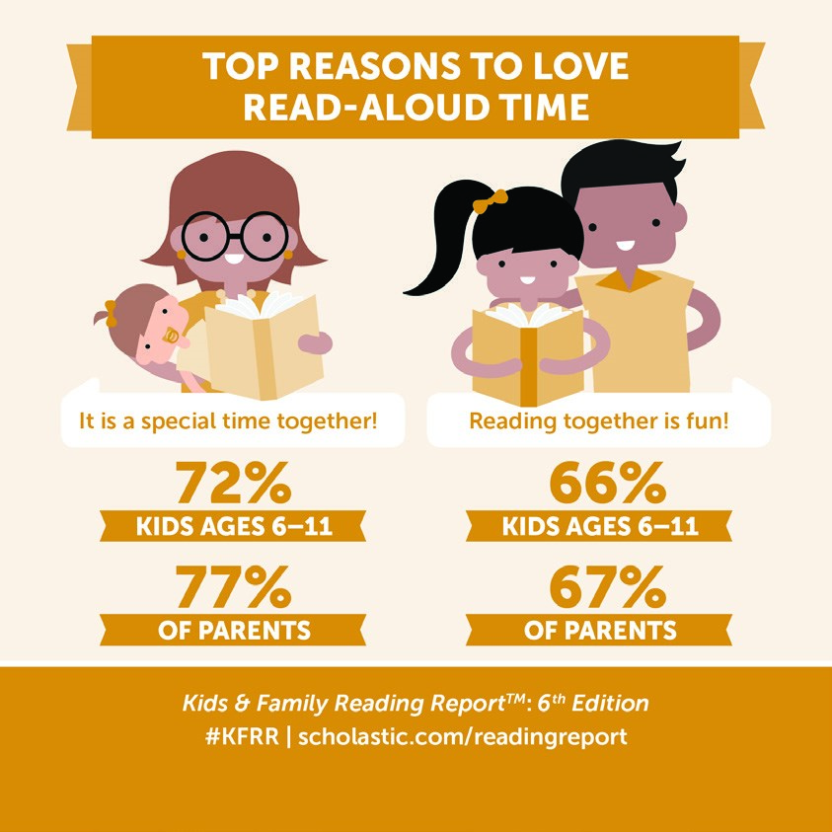

Dear Magnet Parents and Families:
Reading an average of 20 minutes per day is one of
the easiest ways to build your child’s vocabulary and
reading skills while improving his or her grades! Kids
love reading with their family and they enjoy it even
more when they choose their own books.
Use the following tips to encourage your reader:
•

Read aloud as a family.
•

Keep book
s in your home. Each addition to your
home library helps your child get a little further in
school.
•

Visit the library and let your child choose his or her
own books.
•

Read what your child is
reading and discuss the story.
•
Set the example. Children are inspired when they see you reading too.
•
Bring your child to the Book Fair and discover new books together.
Our Scholastic Book Fair features a wide range of engaging and affordable books for every age.
Your child is certain to find a book they will love! Please make plans to visit
our Book Fair.
Book Fair dates: March 12th thru March 16Th, 2018
Shopping hours: From 11:18 am. to 1:30 Pm & 3:00 to 3:15 pm.
Before you visit, download the Book Fairs app and talk about the books your child finds
interesting. Search “Book Fairs” in the app store or visit
scholastic.com/apps/bookfairs
If you cannot attend in person, shop our Online Fair from March 7th
to March 20 at
scholastic.com/fair
.
We can’t wait to see you at our Book Fair! Remember, all purchases benefit our students. Thanks
for supporting our readers!

© 2018 Scholastic Inc. All rights reserved. 14427 S1
8 300273
Permission to reproduce this item is granted by Scholastic Book Fairs®.

